Shooter Game

**Your launcher**



This is your launcher. Use the left and right arrow keys on your keyboard to move it either left or right.

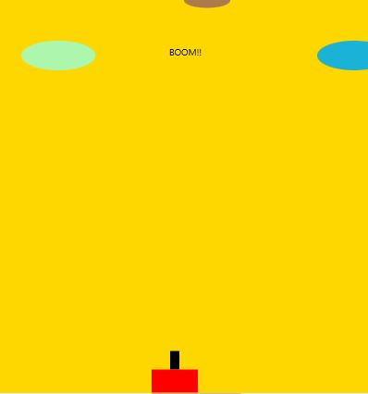

Use the spacebar on the keyboard to fire at an invader.



Smaller invaders are worth 100 points



Larger invaders are worth 50 points